EC-341 Digital System Design
BS(CE)-2021
LAB REPORT # 06

Submitted By:
Reg. No. | Name
21-CE-009 | Huzaifa Shahbaz
21-CE-021 | Yawar Ali Malik
21-CE-020 | Muhammad Ibthesam Khan

Department of Computer Engineering
BS Computer Engineering Program
HITEC University Taxila
 | Presentation  (Format(0.5)+Title (0.5)+  Conclusion(1)+Procedure(2)+Objective(1)) | Calculation/Coding | Observation/ Program Results | Total
Total | 5 | 5 | 5 | 15
Obtained

___________________________
Lab Instructor.
Engr. Fasih Ahmad
Experiment #06
Analysis of Implementation of Combinational Circuits
Using Different Approaches
Decoders and Multiplexers
Objective
- Combinational Circuits
- Implementation using Discrete Gates
- Implementation using Decoders
- Implementation using Multiplexers
- Lab Tasks
Software Used
- Vivado
Tasks
Task 1
Half adder Gate-Level
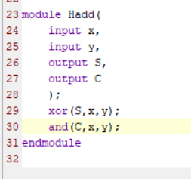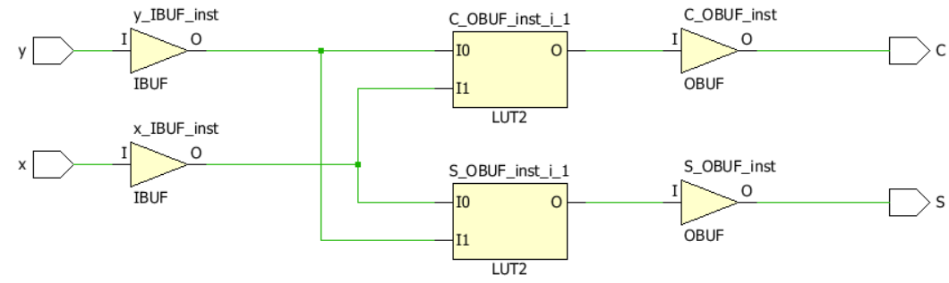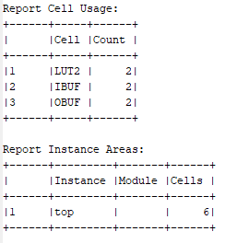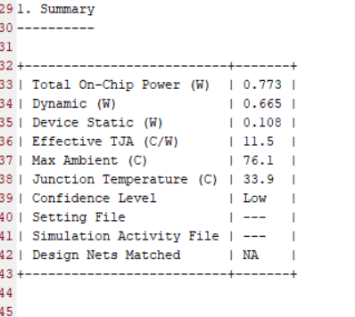
Half adder Behavior level
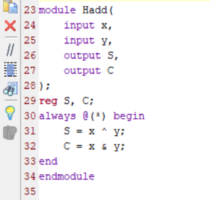
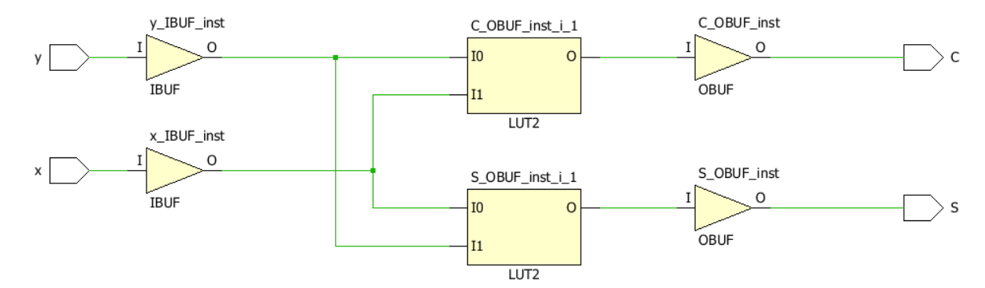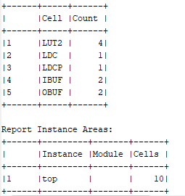
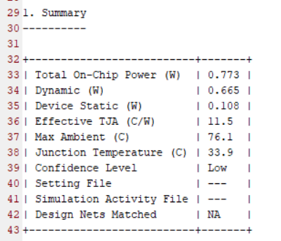

Full Adder
Gate level Implementation
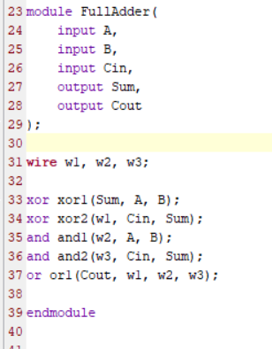
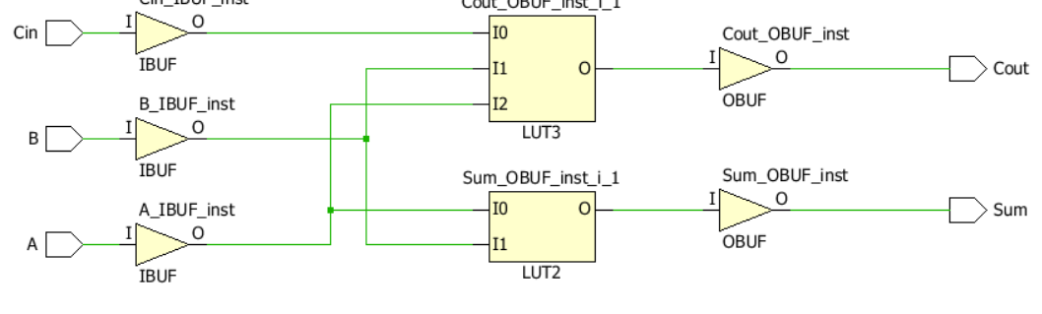

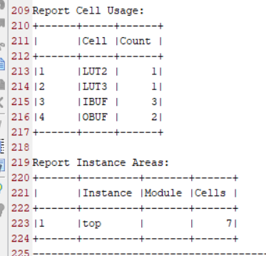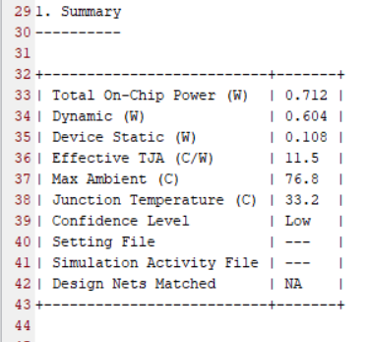
Full Adder Behavior Level
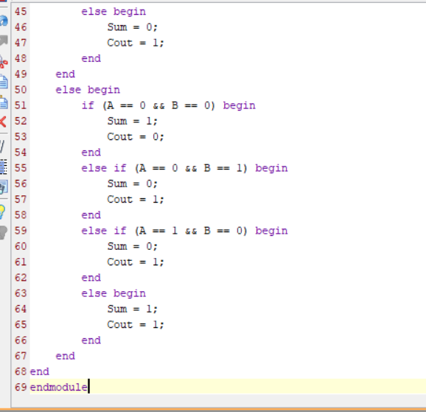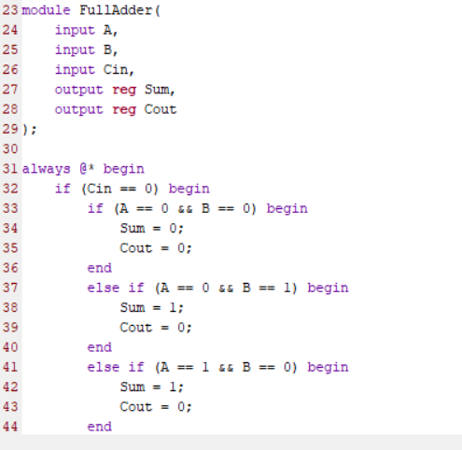

=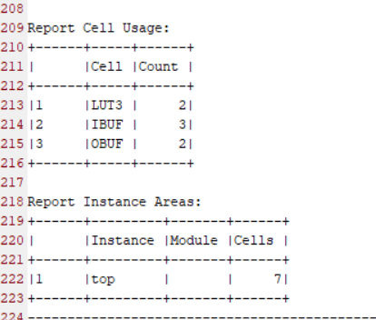
Task 2
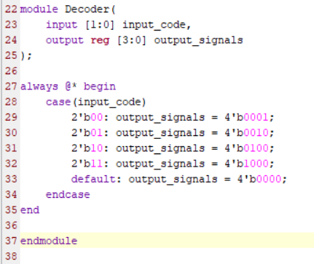
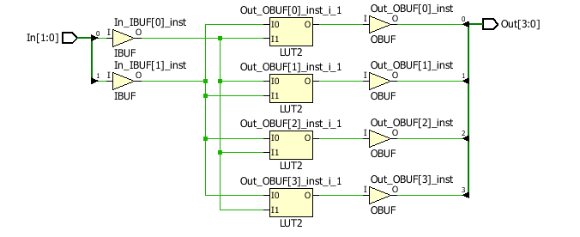

Task 3
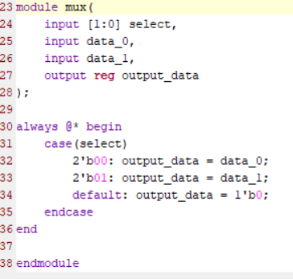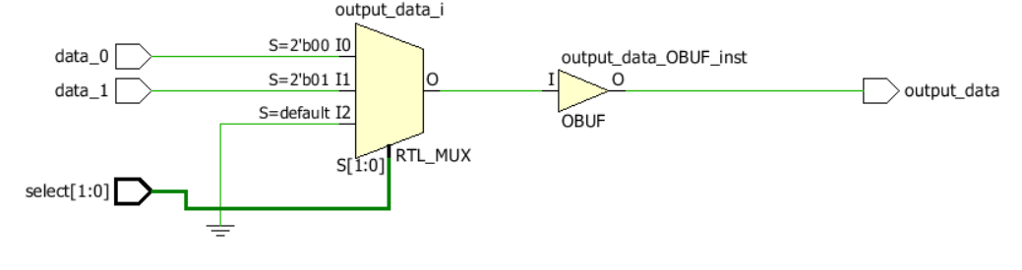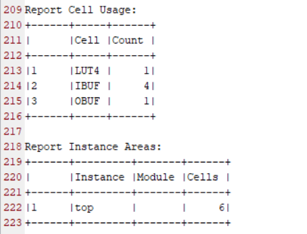
Conclusion
In this lab we implemented different combinational circuits like half adder, full adder, decoder and mux.

